Step1: Go to General Settings => Integrations => Website Lead Integration
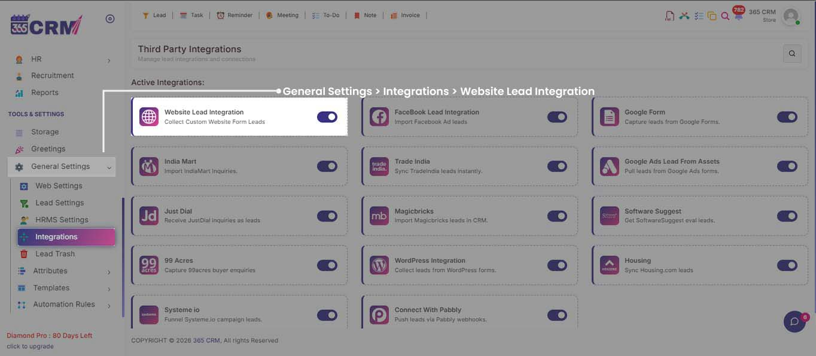

Step2: Go to Website Lead Integration => Select Lead Label
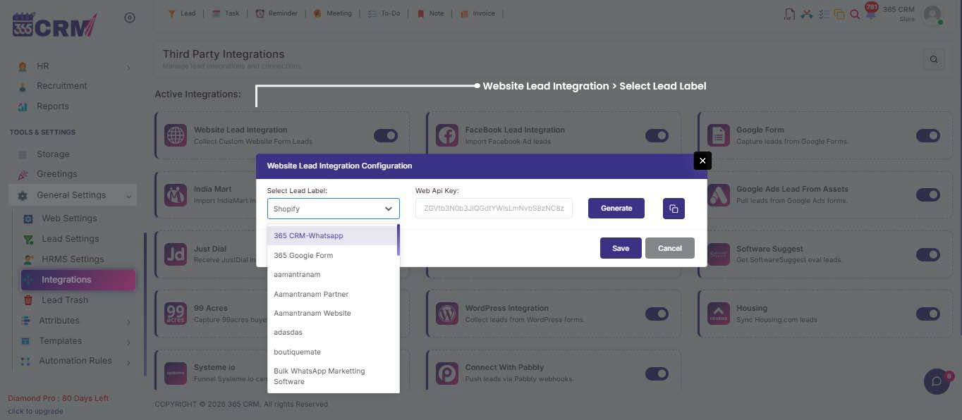

Step3: Go to shopify dashboard => Settings
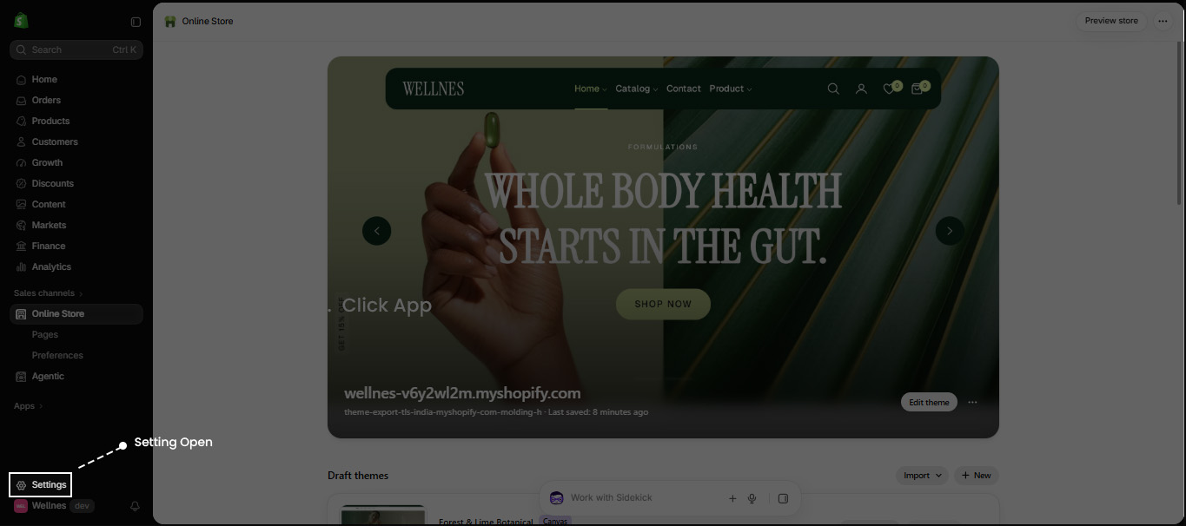
Step 4: Go to Apps => Shopify App Store
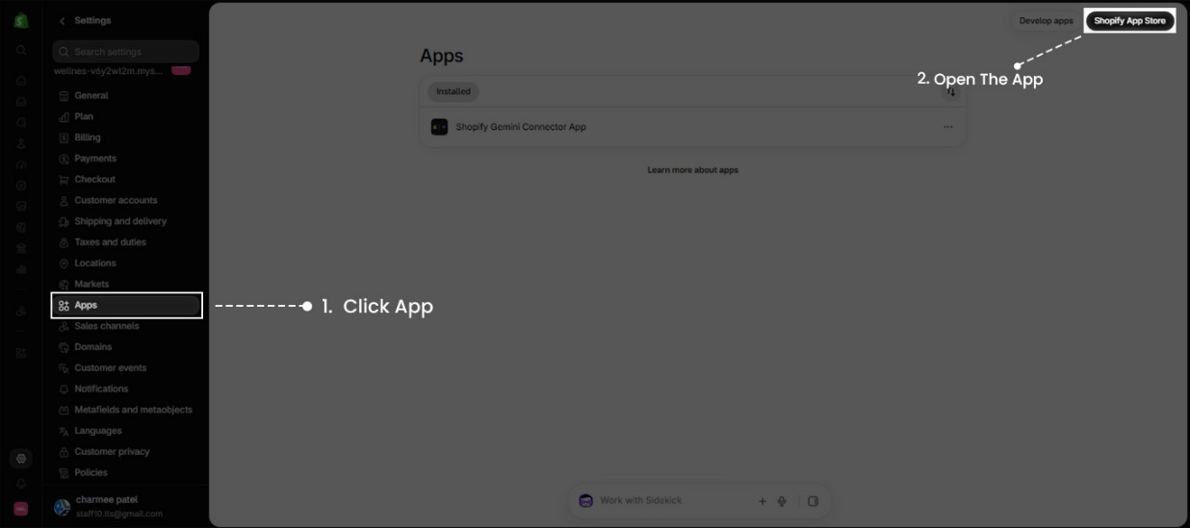

Step 5: Search Flow apps => Install
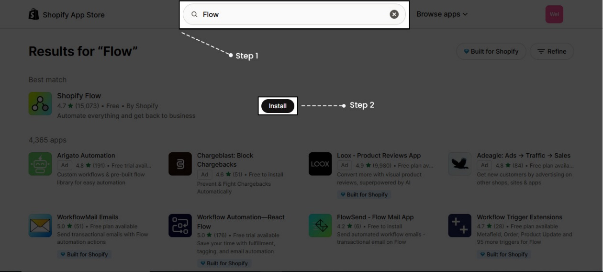

Step 6: Go to Settings => Add Secret
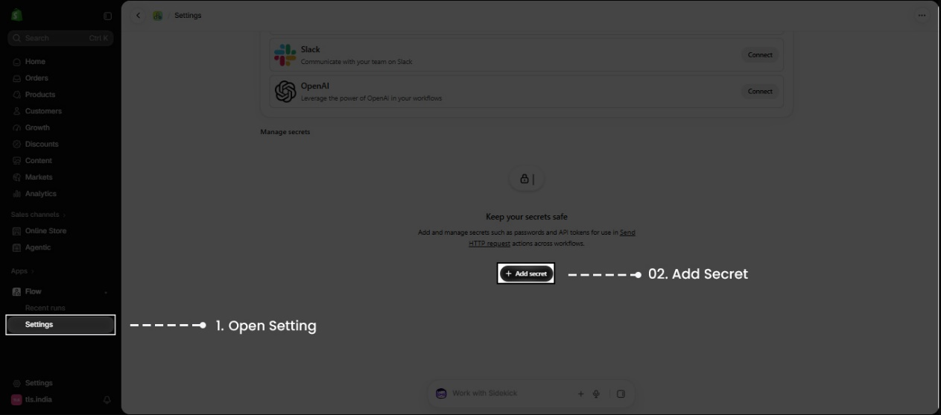
Step 7: Name : crm_api_key => Secret value: Enter the CRM API Key=> Description: 365 CRM API Key for Shopify Flow
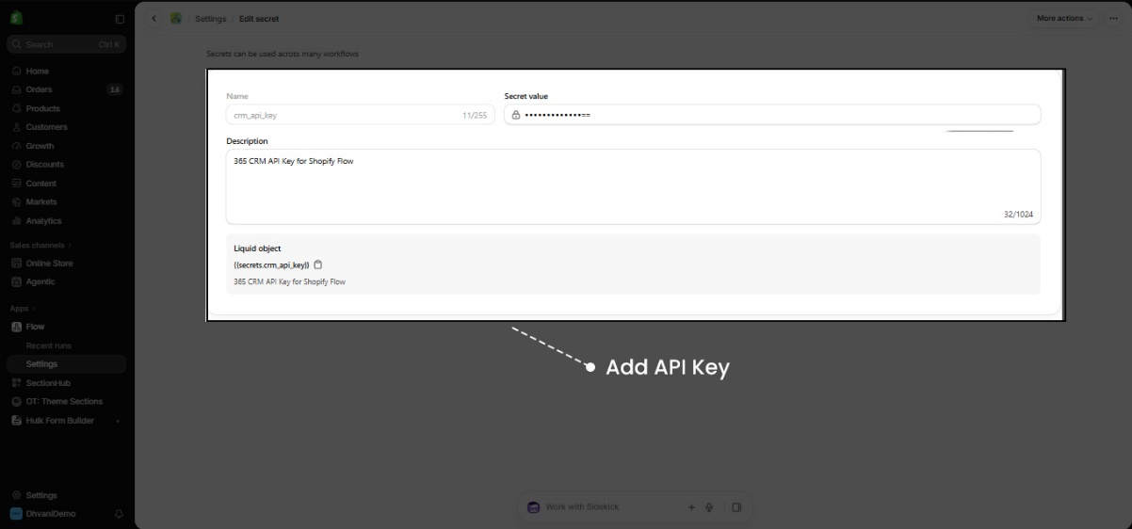

Step 8: Go to Flow App => Create Workflow
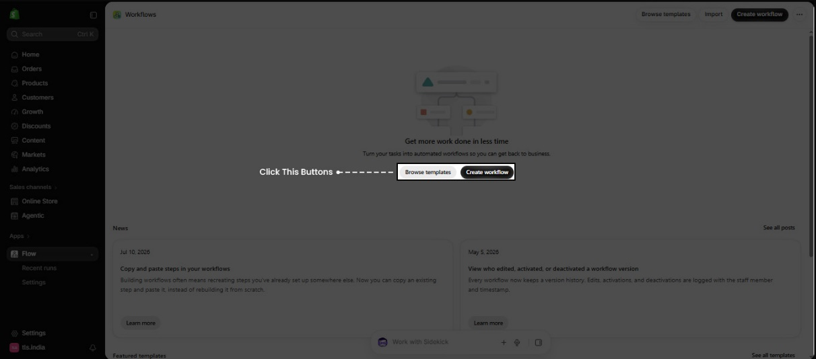

Step 9: Select A trigger
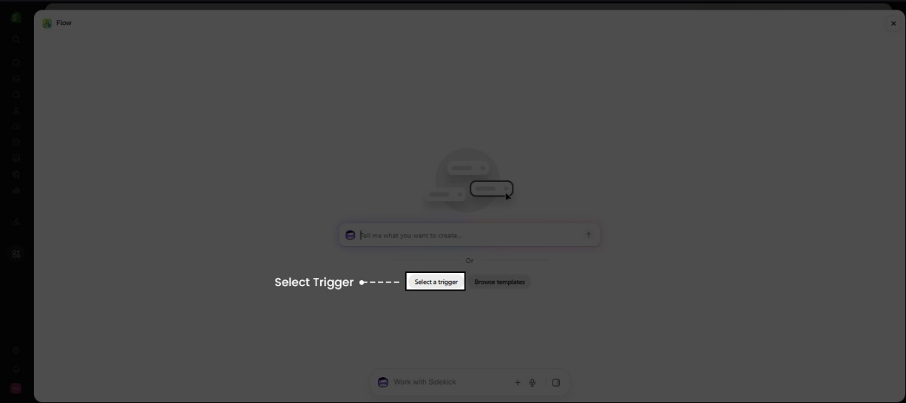
Step 10: Go to Search Order created => Select Order Created
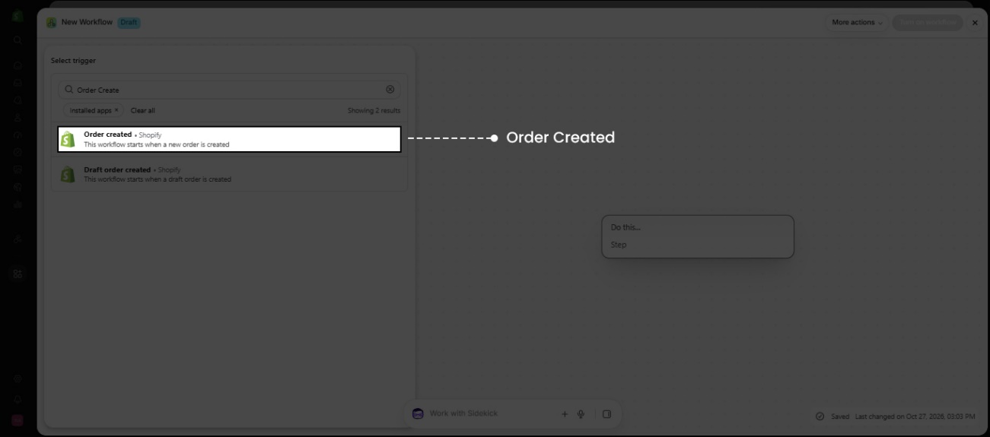

Step 11: Select Action
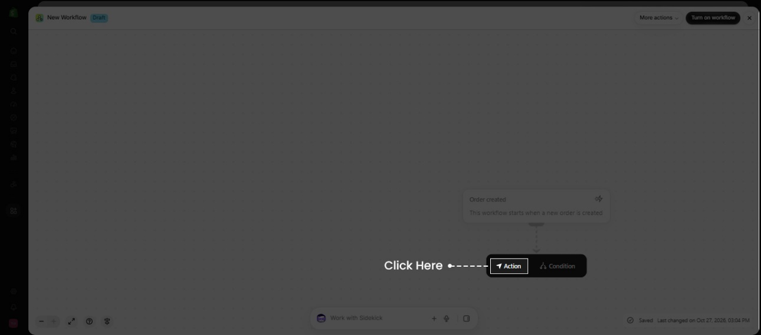

Step 12: Go to Search Send HTTP request => Select Send HTTP request
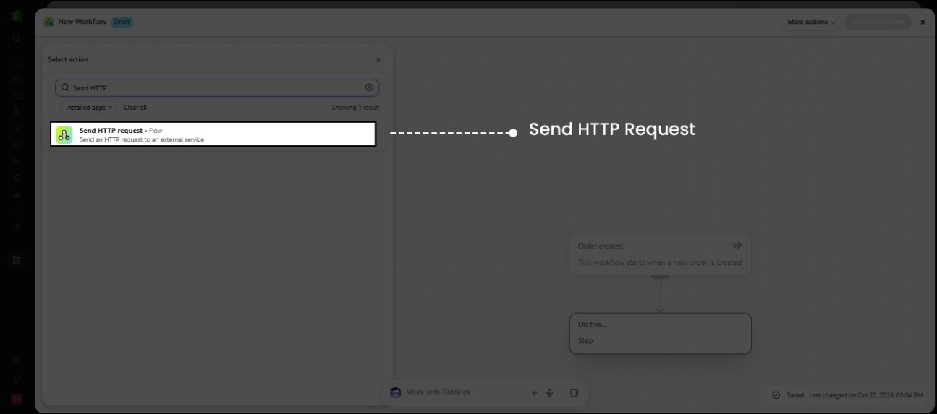
Step 13 Set HTTP Method to Post => Enter the CRM Endpoint URL => Fill in the Header Key & Value fields => Add the Required Code to the Request Body.
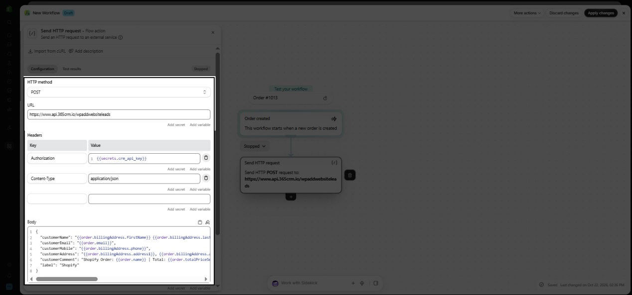

Form Submit Lead
{%- if section.settings.crm_endpoint != blank and section.settings.crm_api_key != blank -%}
<script>
(function () {
var form = document.getElementById('ContactForm');
if (!form) return;

var CRM_ENDPOINT = {{ section.settings.crm_endpoint | json }};
var CRM_API_KEY = {{ section.settings.crm_api_key | json }};
var CRM_LABEL = {{ section.settings.crm_label | json }};
var COUNTRY_CODE = {{ section.settings.crm_country_code | default: '91' | json }};

// Format the mobile number with the country code required by the CRM (e.g 919876543210)

function formatMobile(raw) {
var digits = (raw || '').replace(/\D/g, '');
if (digits.length === 10) return COUNTRY_CODE + digits;
if (digits.length === 11 && digits.charAt(0) === '0') return COUNTRY_CODE + digits.slice(1);
return digits;
}

form.addEventListener('submit', function () {
var nameEl = document.getElementById('ContactForm-name');
var emailEl = document.getElementById('ContactForm-email');
var phoneEl = document.getElementById('ContactForm-phone');
var bodyEl = document.getElementById('ContactForm-body');

var payload = {
customerName: nameEl ? nameEl.value.trim() : '',
customerEmail: emailEl ? emailEl.value.trim() : '',
customerMobile: formatMobile(phoneEl ? phoneEl.value : ''),
customerComment: bodyEl ? bodyEl.value.trim() : '',
label: CRM_LABEL
};

// Send the lead to the CRM

try {
fetch(CRM_ENDPOINT, {
method: 'POST',
headers: {
'Authorization': CRM_API_KEY,
'Content-Type': 'application/json'
},
body: JSON.stringify(payload),
keepalive: true
}).catch(function (err) {
console.warn('CRM lead send failed:', err);
});
} catch (err) {
console.warn('CRM lead send error:', err);
}
});
})();
</script>
{%- endif -%}
Add Schema
{
"type": "header",
"content": "CRM Integration"
},
{
"type": "text",
"id": "crm_endpoint",
"label": "CRM endpoint URL"
},
{
"type": "text",
"id": "crm_api_key",
"label": "CRM API key"
},
{
"type": "text",
"id": "crm_label",
"label": "CRM Lead label",
"default": "shopify"
},
{
"type": "text",
"id": "crm_country_code",
"label": "Default country code (10 digit)",
"default": "91"
},

